**Download and Install JMeter**

1. Download JMeter

Go to the Apache jmeter download page and select the appropriate release for your machine. Because I'm using a Windows 10 computer, I downloaded the zip file. Extract the downloaded package to a desired location.

1. Start JMeter

To run the jmeter, go to the folder the /jmeter/bin and run jmeter.bat file.

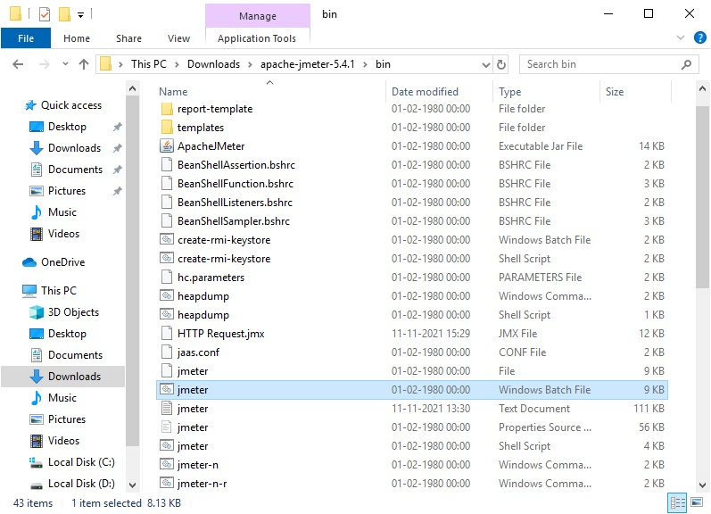

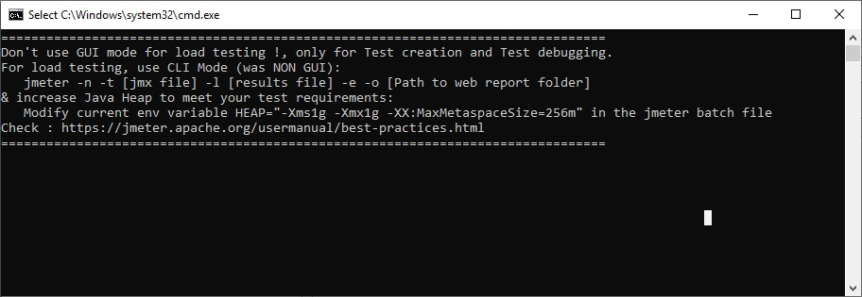

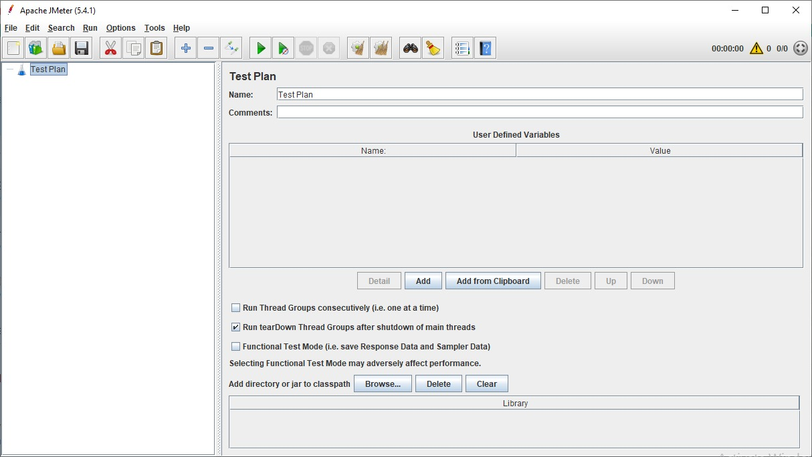

1. Create test plan

A useful test plan is created with minimum 3 components :

Thread Group : contains the simulation of multiple concurrent users. A single thread represent a single user. We can create any number of threads to put the desired load on the application. It also help us in scheduling the delay between two threads, and any repetition of request batches.

HTTP Request : consist the HTTP request configuration which thread group will be invoking. It is the application URL which you want to load test.

Listener : helps in viewing the result of the whole testing process. There are multiple listener available in jmeter to verify the testing results.

* Create Thread Group

To create a thread group, navigate to ‘Right click Test Plan -> Add -> Threads -> Thread Group’.

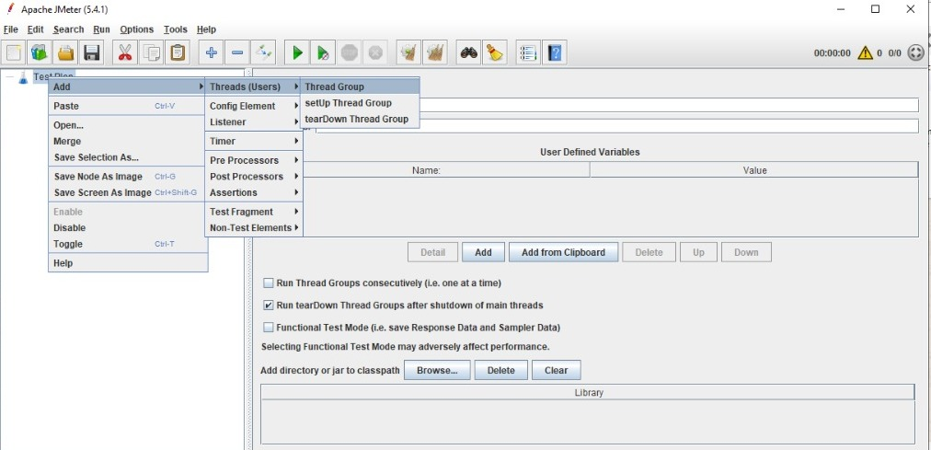

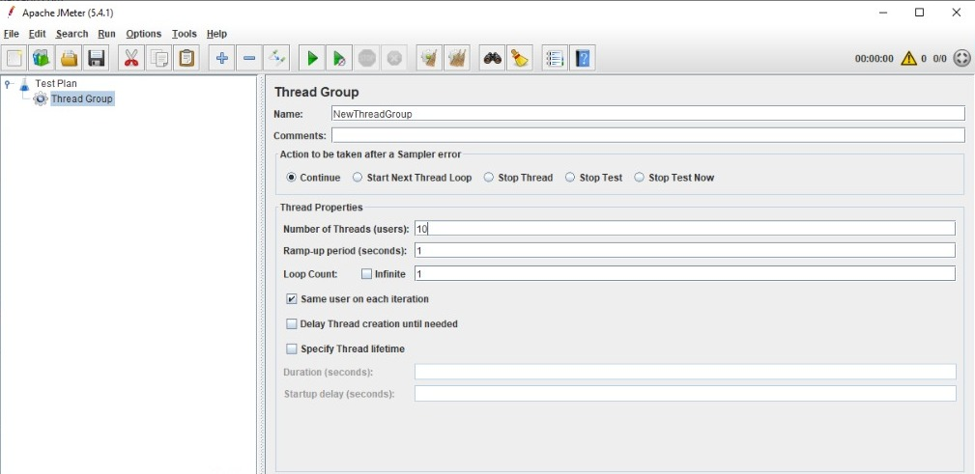

* Create HTTP Request

To add HTTP request details, navigate to ‘Right click thread group -> Add -> Sampler -> HTTP Request’.

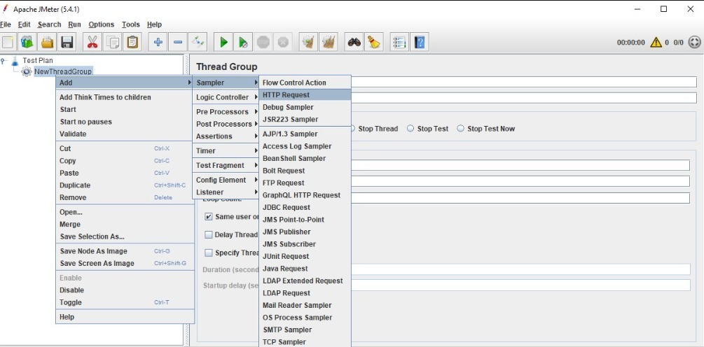

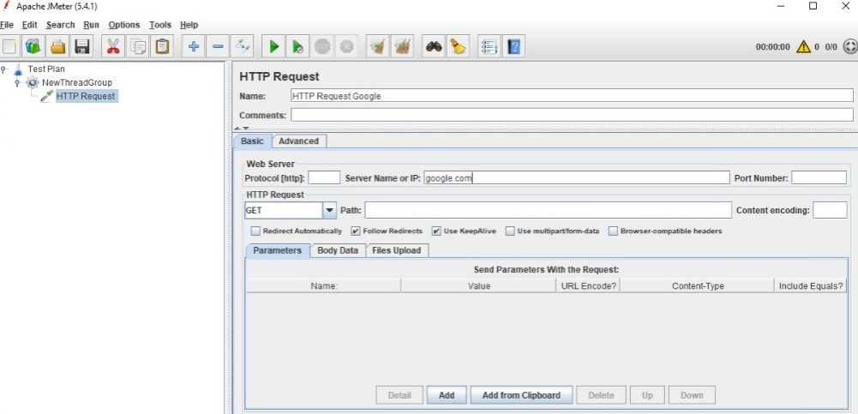

* Add Listener

To see the results of test plan, add listener named “” by navigating to ‘Right click thread group -> Add -> Listener -> View Results Tree’.

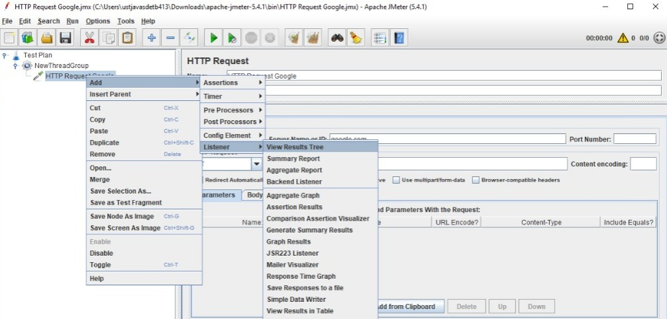

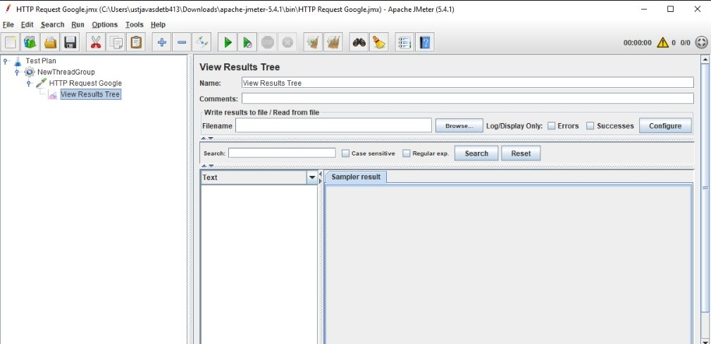

1. Perform load testing

To perform the load testing, start the thread group using the green play icon at the top

ribbon in tool.

